**Detailed Report: Bioreactor System for Insulin Production**

**Table of Contents**

1. **Executive Summary**
2. **System Overview**
3. **Mechanism Overview**
4. **Assumptions and Data Used**
5. **Component Design and Space Allocation**
   * Main Bioreactor
   * Dry Media Storage
   * Buffer Volume
   * Mixer
   * Gas Exchanger
   * Peltier Cooler
   * Battery
6. **Cost Analysis**
   * System Cost
   * Operational Cost (Detailed Breakdown)
   * Cost per Unit of Insulin
   * Lifetime Savings
7. **Conclusion**
8. **Appendices**
   * Appendix A: Detailed Calculations
   * Appendix B: Component Specifications
   * Appendix C: Cost Breakdown
   * Appendix D: References
   * Appendix E: Weight of insulin protein required to produce 200 units of insulin

# Appendix F: Insulin Purification part I

* + **Appendix G: Insulin Purification Part II**
  + Appendix H: Column and Resin Calculations
  + Appendix I: Notes

**3d model prototype to scale**

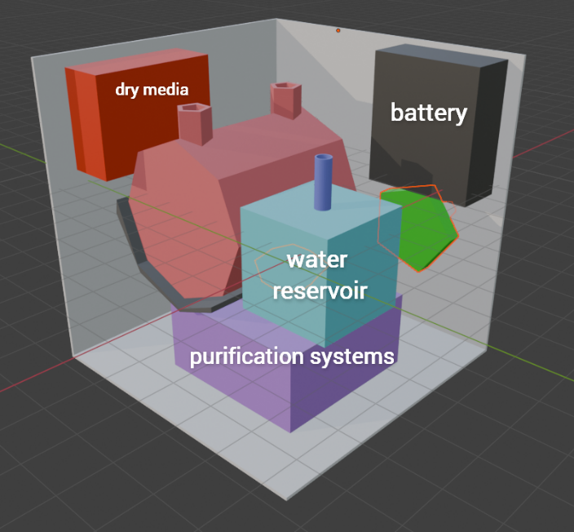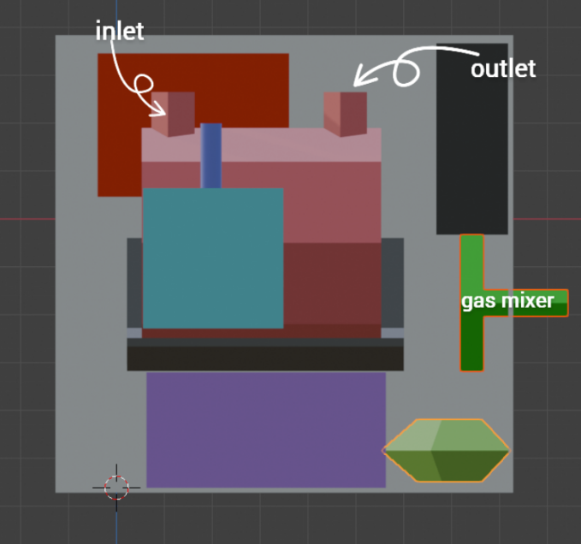

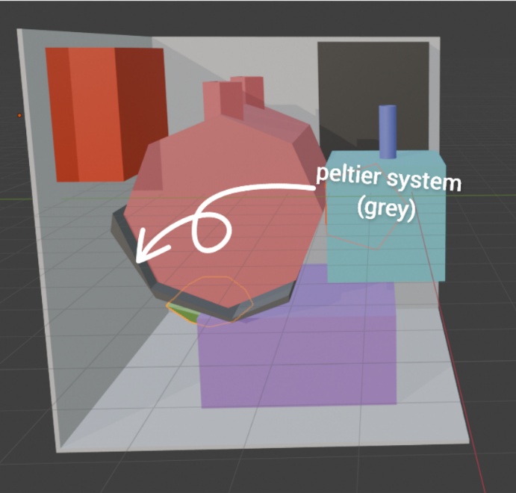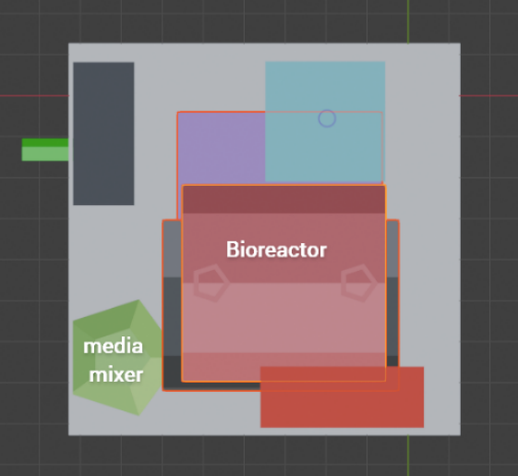

**1.The second bioreactor is not explicitly shown, as it is assumed to be incorporated within the volume of the main bioreactor.**

**2. The connecting wires and fluid flow system are not depicted. However, the following connections exist:**

* **The water reservoir and dry media storage are connected to the media mixer, which is also attached to a gas exchanger/pump/mixer.**
* **The media mixer is primarily connected to the main entry side of the bioreactor, where the media flows into the bioreactor. The media then exits from the opposite side of the bioreactor and returns to the mixer. The media mixer is also connected to the inlet valve of bioreactor.**
* **The inlet and outlet valves are used specifically for insulin extraction, with the outlet valve leading to the insulin purification system (depicted in purple).**
* **The battery is connected to the Peltier system to power it.**

**Schematic Diagram showing working of the Bioreactor.**

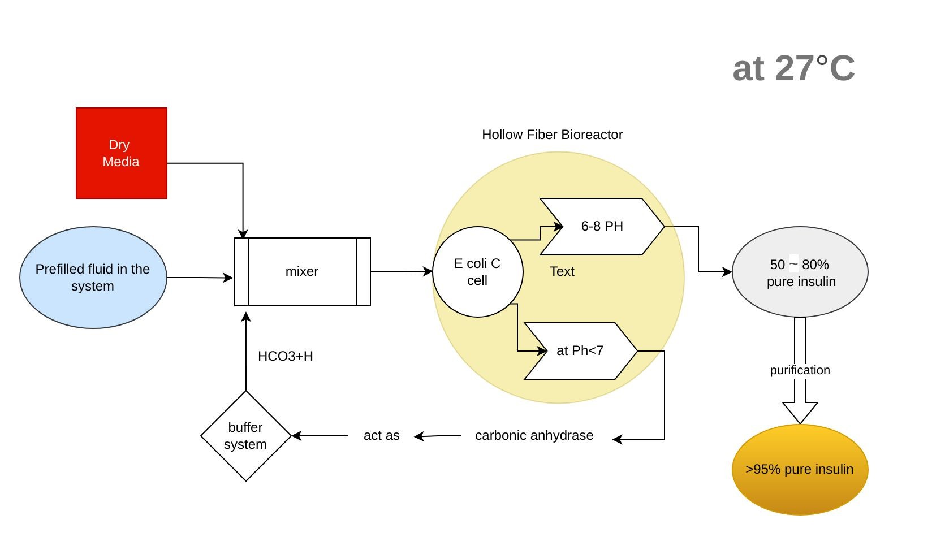

Notes.  
1. The same Processes will continue at 4 c but at less than 90% capacity (Q10 rule).  
2. The system forms a closed loop system which does not require any external buffer or media other than dry media powder which takes minimally less space.

**Plasmid Designed for Use-**

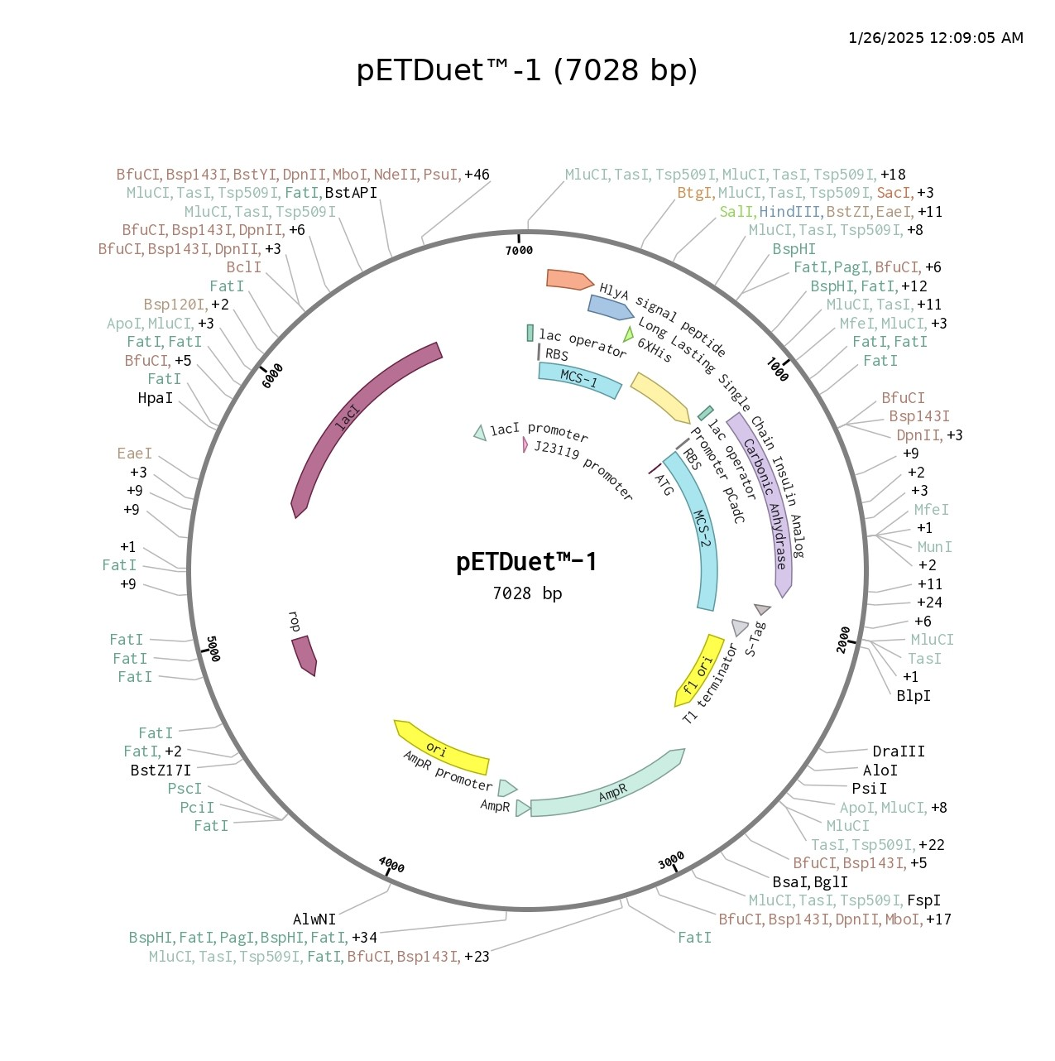

**Notes**.

1. Original T7 promoter before MCS 1 has been replaced by J23119(strong promoter  
   ).
2. Original T7 promoter before MCS 2 has been replaced by PCadC(low Ph induced promoter).
3. Gene inserts in MCS 1- HlyA signal peptide-single chain long-acting insulin analogue-His tag,
4. Gene inserts in MCS 2- Carbonic anhydrase (activated during low Ph due to PCadC)
5. T7 terminator has been replaced by T1 terminator.

**Insulin Purification Method.**

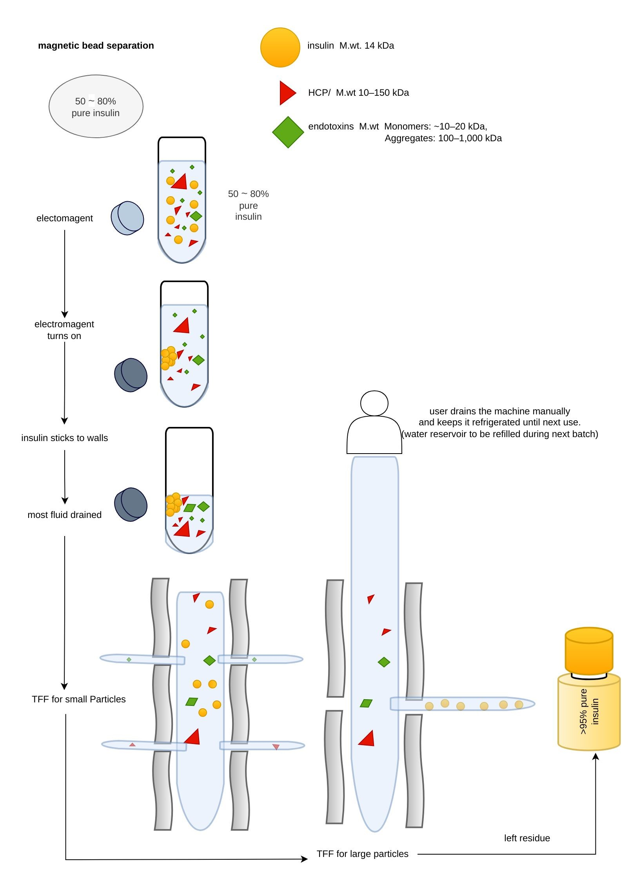

**1. Executive Summary**

This report outlines the design, cost, and space requirements of a **bioreactor system** capable of producing **200 units of insulin** in **37.86 minutes**. The system is compact, efficient, and cost-effective, with significant savings compared to the US market price of insulin. The total system volume is **0.614 L**, housed in a **cube-like enclosure** with dimensions **8.5 cm × 8.5 cm × 8.5 cm**. The system includes a **main bioreactor**, **dry media storage**, **Water Reservoir**, **mixer**, **gas exchanger**, **Peltier cooler**, and **battery**. The **lifetime savings** for a diabetic patient using this system over 50 years is **$ 846,500**. The system requires refrigeration when not in operation to keep media consumption low and can Keep itself refrigerated during transport for **3 hours** or longer with continuous charging.

**2. System Overview**

The bioreactor system is designed to:

* Produce **200 units of insulin in 37.86 minutes** (per batch).
* Utilize a **dry media mixing system** for glucose-containing media.
* Maintain the system at **4°C** when not in operation inside a **refrigerator**.
* Be housed in a **cube-like enclosure** for compactness and portability.
* Be stored in a **refrigerator** when not in operation to maintain stability.

**4. Assumptions and Data Used**

1. **Recombinant Protein Production:**
   * Specific protein production rate: , average:  (lower end for conservative estimates). (Appendix D1.1)
   * System used: **Strong Promoter with medium-copy-number plasmid in E. coli**.
   * medium-copy-number plasmid: Allows up to
2. **Cell Density:**
   * (lower than high-density cultures for conservative estimates). (Appendix D1.2)
3. **Insulin Yield:**
4. **Media Composition:**
   * Glucose-based media with concentration.
   * Dry media makes up
5. **Buffer Production:**
   * A **genetic circuit** is used to produce **carbonic anhydrase** for buffer regeneration during low pH.
6. **System Volume:**
   * Total available space:  (cube with sides).
7. **Cooling and heating Requirements:**
   * Warm device to room temp when in taken out of refrigeration.
   * Keep the device refrigerated during transport for until 3 hours or till a charging port is found.
8. Battery:

**5. Component Design and Space Allocation**

**5.1 Main Bioreactor**

* **Purpose:** Insulin production using recombinant E. coli.
* **Insulin Needed:**
* **Protein Production Rate:**
* **Space Required:**
* **Total Volume:** To allow for scaling, mixing, and headspace, volume is set at **0.22 L**.
* **Production Time:**

**5.2 Dry Media Storage**

Needed to produce of insulin analogueof 14 kDa molecular weight (see Appendix E)

* Assuming 33% of media protein goes to fuel towards production of insulin (see Appendix D1.)

**Adjust for 33% efficiency:**

(B1)

**Step 4: Volume of Dry Media**

Density of dry media is **.**(**Terrific Broth** is being used here) ()

.

Making it 0.05 L so it can be used multiple times.

**Final Answer:**

* **Media volume required: 17.36 L.**
* **Dry media weight: 34.72 g.**
* **Dry media volume: 0.0579 L (approximately 58 mL).**

**5.3 Mixer/** **peizoelectric pump Complex**

* **Purpose:** Ensure homogeneous mixing of the media and pump it to bioreactor.
* **Mixer Volume:**
* **Why 0.15 × 0.22 L?**
  + The mixer volume is typically **10–20% of the bioreactor volume** to ensure efficient mixing without taking up too much space.
  + For a **0.22 L bioreactor**, a mixer volume of **0.033 L** (15% of 0.22 L) is sufficient.

**a piezoelectric pump of negligible volume (0.00128 L) capable of flow rate of **~135 mL/min** will also be inside this complex **(see **Appendix F**)

* **Final Mixer Volume:** Rounded to **0.05 L**.

**5.4 Gas Exchanger**

* **Purpose:** Facilitate oxygen transfer and CO₂ removal.
* **Oxygen Demand:**
* **CO₂ Production:**

CO₂ Production=0.18 mol CO₂/hour.

* **Gas Exchanger Volume:** A compact sparger or membrane module with a volume of **0.06 L** is sufficient.

**5.5 Water Reservoir**

* **Purpose:** To provide Wet Media for the system to continue function
* The total space required for water reservoir is assumed to be equal to volume of individual compartments it will flow through, and then adding an additional 5% to account for the space taken up by connecting pipes.
* Component Volumes:
* Bioreactor: 0.22 L
* Dry Media Storage: 0.05 L
* Mixer: 0.05 L
* Gas Exchanger: 0.06 L
* Total Volume of water required/batch =

**Water Reservoir Volume** required is 0.38 L

* 1. **Peltier System**

**Given Data:**

* **Mass: 380 g**
* Specific Heat Capacity **(c):**
* Room Temperature**: 21 °C (**assuming cells get active at 21**°**C**)**
* Refrigeration Temperature**: 4 °C**
* Energy Density of Li-ion Battery**:**

**Heating to room Temp (**21**) in 10 minutes**

* **Purpose:**  Warm device to room temp when in taken out of refrigeration.
* **Energy Required for One Heating Cycle:**

Convert to watt-hours:

For 3 cycles:

* **Power Required for Heating:**
* **Battery Volume Required:**

**Peltier Cooling at 4°C for 3 Hours:**

* **Purpose:**  Keep the device refrigerated during transport for until 3 hours or till a charging port is found.
* **Mass: 380 g**
* **Specific Heat Capacity (c): 4.18 J/g°C**
* **Temperature Difference (ΔT): 17 °C (**assume it needs to be heated to 21**°**C**)**
* Time: 3 hours = **10,800 s**
* Energy Density of Li-ion Battery**: 250 Wh/L**

Energy **Required:**

* Converting to watt-hours,

**Power Required:**

* **Battery Volume Required:**

**Energy, Power, and Battery Requirements Summary:**

1. **Cooling to 4°C for 3 Hours:**
2. **Heating from 4°C to 21°C in 10 Minutes (×3):**
   * (**taking the bigger volume as it will be doing only one of the desired functions at a time**)
   * Assuming 200 ml of insulin can keep **4–7 days** for someone with moderate insulin requirements (e.g., 30–50 units/day).
   * The device needs to be powered only once a month.

**Space Allocation Table**

**﻿**

| **Component** | **Volume (L)** | **Space Left (L)** |
| --- | --- | --- |
| **Main Bioreactor** | **0.22** | **0.394** |
| **Dry Media Storage** | **0.05** | **0.344** |
| **Mixer/piezoelectric pump** | **0.05** | **0.294** |
| **Gas Exchanger** | **0.06** | **0.234** |
| **Peltier Cooler** | **0.03** | **0.204** |
| **Battery** | **0.07** | **0.134** |
| **Total Used Space** | **0.54 L** | **0.134 L﻿** |

**6. Cost Analysis**

**6.1 System Cost**

* **Main Bioreactor:** $500
* **Dry Media Storage:** $50
* **Buffer Volume:** $30
* **Mixer:** $100
* **Gas Exchanger:** $150
* **Peltier Cooler:** $200
* **Battery:** $100
* Automated Monitoring System: Cost: $200
* **Total System Cost:** $1,130
* **\*\*Chatgpt also update the cost to all the things I’ve added now(resins etc in the cost of one time production)\*\***

**6.2 Operational Cost (Detailed Breakdown)**

The operational cost includes the following components:

1. **Media Cost:**
   * **Glucose-based media:** $10/L.
   * **Media volume per batch (200 units):** 1.44 L.
   * **Cost per batch: = 14.40$**
2. **Electricity Cost:**
   * **Peltier cooler power consumption:** 20 W.
   * **Operation time per batch:** 0.63 hours (37.86 minutes).
   * **Energy consumed per batch:**

.

* + **Electricity cost:** $0.12/kWh.
  + **Cost per batch: = (**rounded off to 0.01 for any extra need that may arise)

1. **Total Operational Cost per Batch (200 units):**

**6.3 Cost per Unit of Insulin**

* **Operational Cost per Batch (200 units):** $14.41.
* **Cost per Unit:**  = $0.072 per unit.

**6.4 US Market Cost per Unit**

* **US Market Price:** $100 per 100 units.
* **Cost per Unit:**

Cost per Unit=  = $1 per unit.

**6.5 Lifetime Savings**

* **Savings per Unit: $1.00−$0.072 = $0.928 per unit.**

**2. Total Insulin Needed Over 50 Years**

* **Daily Insulin Requirement: 50 units (average for Type 1 diabetes).**
* **Annual Insulin Requirement:**
* **Lifetime Insulin Requirement (50 years):**

**3. Lifetime Savings**

* **Savings per Unit: $0.928.**
* **Total Lifetime Savings: =**

**7. Conclusion**

The bioreactor system is a **compact, efficient, and cost-effective solution** for insulin production. With a **lifetime savings of** compared to the US market, it offers significant financial benefits. The **cube-like design** ensures portability and ease of use, while the **conservative assumptions** provide a realistic and reliable system.

**8. Appendices**

**Appendix A: Detailed Calculations**

1. **Main Bioreactor:**
   * Protein production rate: 20 pg/cell/hour.
   * Cell density: 5 × 10⁹ cells/cm³.
   * Insulin needed: 6.94 mg.
   * Volume required: 69.4 cm³ (0.0694 L).
   * Total volume with headspace: 0.22 L.
   * Production time: 37.86 minutes.
2. **Dry Media Storage:**
   * Media volume per batch: 1.44 L.
   * Dry media volume: 0.0144 L (14.4 mL).
   * Storage volume: 0.05 L.
   * Insulin production capacity: 694 units.
3. **Buffer Volume:**
   * Buffer volume: 0.10 L.
   * Buffer regeneration using carbonic anhydrase.
4. **Mixer:**
   * Mixer volume: 0.033 L (15% of bioreactor volume).
   * Final mixer volume: 0.05 L.
5. **Gas Exchanger:**
   * Oxygen demand: 0.18 mol O₂/hour.
   * CO₂ production: 0.18 mol CO₂/hour.
   * Gas exchanger volume: 0.06 L.
6. **Peltier Cooler:**
   * Heat load: 19,326 J.
   * Power required: 5.37 W.
   * Battery capacity: 20 Ah.
   * Battery volume: 0.03 L.

**Appendix B: Component Specifications**

* **Main Bioreactor:** 0.22 L, E. coli-based insulin production.
* **Dry Media Storage:** 0.05 L, glucose-based media.
* **Mixer:** 0.05 L, magnetic stirrer, or impeller.
* **Gas Exchanger:** 0.06 L, sparger, or membrane module.
* **Peltier Cooler:** 0.03 L, 10 W cooling capacity.
* **Battery:** 0.04 L, 12V 40Ah.

**Appendix C: Cost Breakdown**

* **System Cost:** $1,130
* **Operational Cost:** $14.41 per batch (200 units)
* **Cost per Unit:** $0.072
* **Lifetime Cost:** $71,350
* **Lifetime Savings:** $841,150

**Appendix D: References**

D1.1.- <https://microbialcellfactories.biomedcentral.com/articles/10.1186/s12934-019-1057-5?utm>

D1.2.- <https://pubmed.ncbi.nlm.nih.gov/8867291/>

D1.3.- <https://pmc.ncbi.nlm.nih.gov/articles/PMC7162232/?utm_>

<https://microbialcellfactories.biomedcentral.com/articles/10.1186/s12934-022-01917-y>

D1.5.- <https://pmc.ncbi.nlm.nih.gov/articles/PMC6410518/?utm_>

Based on SDS-PAGE analysis, the initial harvest typically achieves **~30–50% purity**, with the target protein being the dominant band. Further purification steps, such as **immobilized metal affinity chromatography (IMAC)/Metal**, can increase purity to **>90%**

D1.6.- <https://www.gugent.com.hk/list/115.html?utm>

D1.7.- <https://assets.thermofisher.com/TFS-Assets/LSG/manuals/MAN0011598_Pierce_ChromaCart_ProteinA_UG.pdf?utm_s>

**https://sci-hub.se/ was used to access all these papers using DOI**

**since HlyA will be cleaved off once it enters periplasm**

Appendix E: Weight of insulin required for 1 unit of insulin

**Step 1: Understand the Relationship Between Weight and Activity**

* **1 unit of insulin** is defined by its **biological activity** (glucose-lowering effect)
* **Natural insulin**: 1 unit ≈ 0.0347 mg (34.7 µg) of insulin by weight (based on its molecular weight of ~5.8 kDa).
* **My insulin analog**: Since it has a higher molecular weight (~15 kDa), the weight required for 1 unit will be proportionally higher.

**Step 2: Using the Molecular Weight Ratio**

The weight of insulin required for 1-unit scales with the **molecular weight ratio** between my analog and natural insulin:

Weight of your insulin per unit = (

* Molecular weight of natural insulin = 5.8 kDa
* Molecular weight of your insulin = 15 kDa
* Weight of natural insulin per unit = 0.0347 mg

**Summary**

* **For your 15 kDa insulin analogue**, 1 unit ≈ **89.6 µg** (0.0896 mg).
* **To create 1 unit of 15 kDa insulin analogue, 89.6 µg** (0.0896 mg) of insulin is required.
* **For comparison**: Natural insulin (5.8 kDa) requires **34.7 µg** for 1 unit.
* The difference arises due to analogue being heavier, but the **biological activity per unit remains the same**.
* For 200 unit of insulin analogue, weight of insulin required is

**Appendix F: Insulin Purification part I:**

**1. Introduction**

The **HlyA (hemolysin A) secretion system** in *Escherichia coli* is a Type I Secretion System (T1SS) that enables the direct translocation of proteins from the cytoplasm to the extracellular medium without a periplasmic intermediate. This system is particularly advantageous for recombinant protein production due to its ability to secrete proteins in a single step, reducing toxicity to the host cell and simplifying downstream purification processes.

In this report, we explore the use of the HlyA secretion system for producing recombinant proteins in a **hollow-fiber bioreactor**, focusing on the initial harvest purity and further downstream processing.

**4. Initial Harvest Purity**

* **Secretion Efficiency**: High secretion efficiency reduces contamination from intracellular proteins. Studies report that the HlyA system can secrete functional proteins with yields of

**For .**

**We already calculated that**

* Assume that **30** **~50% purity** is achieved in the harvest directly out of bioreactor (Appendix D1.5).
* Now, using the formula for the volume of media required:

* Substituting the values:
* But since media used in original study was LB media and terrific media

**Step 1: Calculate Media Volume**

• Luria**-**Bertani **(LB)**:

* Yields is **0.1–0.5 mg/L/OD600**.

• TerrificBroth **(TB)**:

* Yields is **1.0–2.0 mg/L/OD600**,
* Using the higher end of both ranges:
* Using the lower end of both ranges:
* .

volume of TB media that needs to be pumped=

(Taking 4L)

**Appendix G: Insulin Purification Part II**

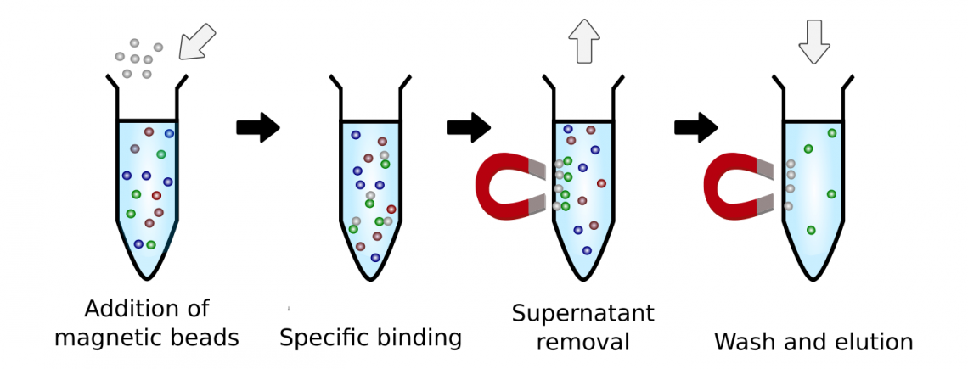

(this diagram is just the basic process; the specific one I’ll be using is on page 3)

In This system

The resin used is Profinity IMAC Resins (Bio-Rad) charged with , which is capable of withstanding 100–200 cycles with consistent performance without the need of recharging.

After washing of solution/ elution will be done by imidazole.

After that, the remaining fluid will go through Tangential flow filtration (**TFF**) twice-

1. To remove particles smaller than 12 Kda(smaller than insulin)

2.To remove particles the size of 14 Kda(size of insulin)

The remaining large size particles are pumped back into the system & is to be drained along with all the fluid after a batch(200 unit) has been prepared.

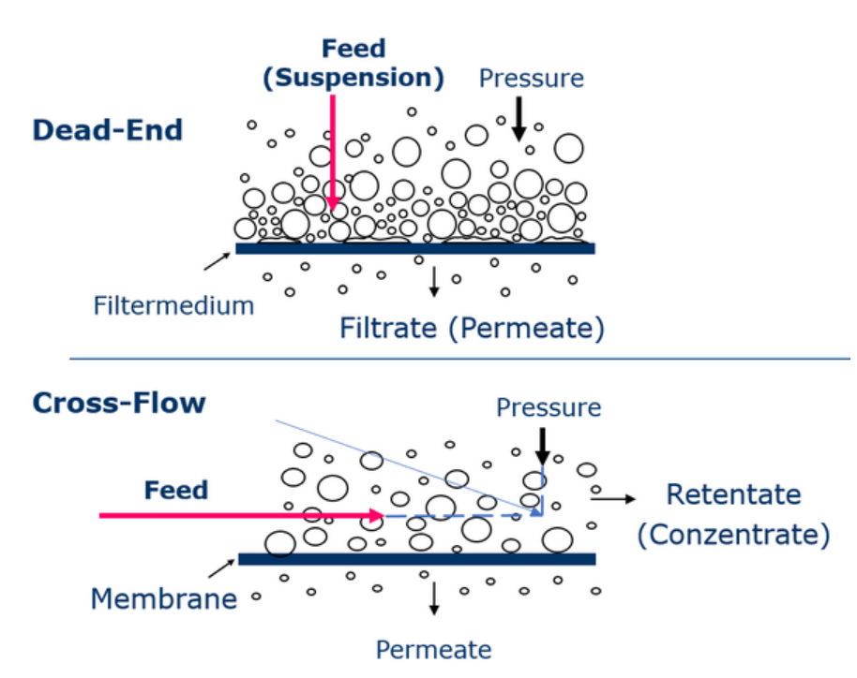

Appendix F: Column and Resin Calculations

**A. Calculation of Resin Requirement:**

To estimate the amount of resin required for your purification, use the following formula:

Assuming column has a binding capacity of **10 mg/mL**, the resin requirement would be:

* + 1. For normal insulin
    2. Our insulin analogue ()

Thus, we will use 1.8 ml column/resin for purification.

**B. Buffer volume-**

Not needed as our system is self-capable of creating buffer during pH fall.

**C. Elution Buffer Volume/weight-**

Since elution is based on no of molecules required, we can use normal weight of insulin here

Each cycle produces 200 units of insulin:

But since resin can be reused at least 100 times, no of cycles will be = 292

**total resin required**

Since 1.8 mL of resin is used per cycle:

Cost= 20$/ml (US)

**Weight of Solid crystal required to make 5ml of Buffer solution:**

Assuming 5ml (~2.5 times Column Volume is needed for 1 batch(Appendix D1.7 ))

**1. Sodium Acetate (50 mM, 5 mL):**

**2. NaCl (300 mM, 5 mL):**

**Total Weight of Dry Salts:**

**To produce 200 unit of insulin, 1.1 g of salt is required**

**For lifetime=**

**Cost of**

* **Sodium Acetate mass (Ratio of Sodium Acetate+** **NaCl=** **0.189+** **0.811):**
* **NaCl mass:**

Calculating cost for US market value (Sodium Acetate **- $58.75**, NaCl **- $10.50**)

Suppose we want to store 5 grams of salt on the machine (4.8 Batches of 200 IU)-

Volume of salt storage must be

Solving with ratio weights of Sodium Acetate and NaCl = 0.60+1.88= 2.48